PARTNER ORGANIZATION FORM

Part I: Overall information
- Organisation’s name: International University - Vietnam National University Ho Chi Minh City (IU-VNU HCMC)
- Organisation’s contact (in Vietnam):
Address: Quarter 33, Linh Xuan Ward, Ho Chi Minh City
Tel: +84 28 3724 4270 | Fax: +84 28 3724 4271
Email: info@hcmiu.edu.vn | Website: https://hcmiu.edu.vn/en/
- Name and designation of the main contact person for this pre-validation.
Name: Assoc. Prof. Dinh Duc Anh Vu
Designation: Vice rector
Email: qlkh@hcmiu.edu.vn
Tel/Mobile: +84 28 3724 4270
- Legal status of the organisation:
(Please send a copy of the document certifying the legal status of the organization)
- In what year was the organisation established? | 2003
- How many full-time equivalent staff does the organisation employ?
- (a) How many of the staff are Vietnamese nationals?
(b) How many volunteer staff work in the organisation?
- What was the total budget (in Euro) of the organisation in the last two financial years?

- What is the organisation’s geographical focus (e.g. regions, provinces)?
National focus in Viet Nam, with principal operations in Ho Chi Minh City and the Southern region. The university also implements education, research, and partnership activities with national and international institutions.

- Have you applied for Embassy of Ireland’s funding support within the last three years? No
- If the answer to Question 10 is yes, please specify the year(s), the amount(s):
Year | Grant code | Amount requested | Amount awarded
N/A | N/A | N/A | N/A

- Will the proposed funding from Irish Aid exceed 70% of the overall organisational income in either of the past two years? No

- What other principal sources of income have supported your organisation in the last two years? Please include any in-country or international fundraising
Year | Donor | Amount | Project/Location

- Governance Structure:
14.1. Please send the organisational chart of the organisation
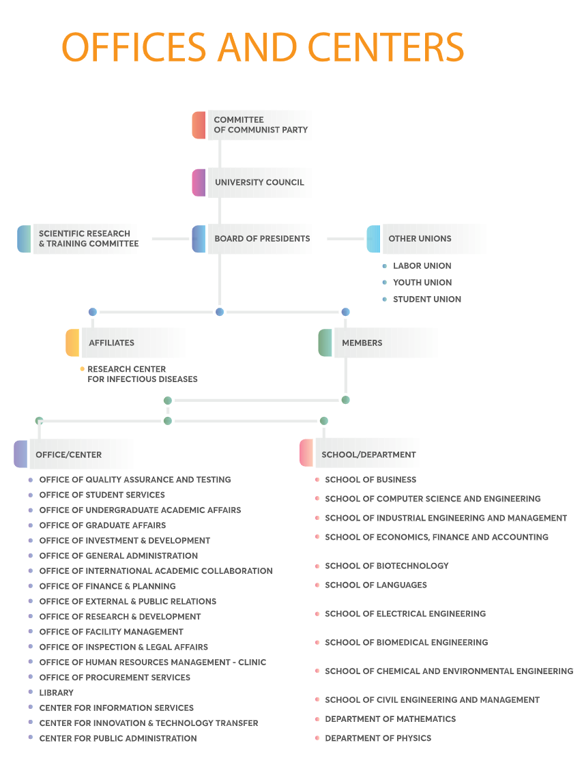
14.2. Does the organisation have a strategic plan? If so, summarise briefly its main points.
Maximum 250 words
Vision/Mission: International University – Viet Nam National University Ho Chi Minh City (IU-VNU) aims to become one of the leading research universities in Asia, nurturing high-quality human resources and contributing to both domestic and international workforce development. The university pursues this vision by becoming an international higher education institution with a Vietnamese cultural identity; pioneering advanced and autonomous higher education governance models; promoting English-medium and globally oriented education, and pursuing excellence in research, innovation, and community engagement to support sustainable socio-economic development.
Strategic objective(s): To strengthen academic quality, research capacity, innovation and technology transfer, international cooperation, community engagement, and institutional governance.
Specific objective(s): Strengthen the university’s autonomous governance and operational efficiency; enhance the internationalization of education and research activities; develop state-of-the-art facilities that meet international standards for training and research.
Key approaches/strategies:
Please note the period of the strategy.

- Monitoring and Evaluation system:
 | Yes | No
15.1. Does the organisation have a standard M&E process for all activities/programmes/projects? | X
15.2. Does the organisation have dedicated staff for M&E? | X
15.3. Does the organisation have an allocated budget for M&E activities? | X
15.4. Does the organisation publish/produce its own annual report? | X
15.5. Does the organisation apply results-based management principles? | X
15.6. Does the organisation have a communication strategy? | X

Part II Financial Management

1 | Annual budget plan | Description/Answer
1.1 | Do you have an annual budget plan? | Yes. The university prepares annual budget plans in line with institutional priorities, VNU-HCM regulations, and approved work plans. Project-level budgets are prepared for each funded activity as required.
1.2 | How often do you have to change your annual budget plan? And who approve? | Budget revisions are made when necessary, typically during periodic financial reviews or when project scope/timeline changes. Revisions are reviewed by the responsible unit and approved by the authorized university/VNU-HCM authority and donor, where required.
2 | Annual financial report
2.1 | Do you have an annual financial report? | Yes. Annual financial reports are prepared in accordance with Vietnamese public-sector accounting regulations and institutional requirements.
3 | Financial management policy/guidelines/manuals
3.1 | Do you have Financial management policy/guidelines/manuals? – (Please send a copy of the guidelines) | Yes. Financial management policies, accounting procedures, and internal regulations are applied. Copies of applicable financial guidelines/manuals can be provided by the Office of Finance & Planning.
4 | Accounting system
4.1 | Do you have separate bank accounts for each Project/Donor
4.2 | Who are the authorized persons signing in the bank accounts?
4.3 | Do you record and classify all the daily transaction to the journal by the end of a day? | Yes. Transactions are recorded and classified in accounting records based on approved supporting documents and institutional accounting procedures.
4.4 | Do you apply accounting software?
4.5 | If not, how often do you input journal/subsidiary ledger to the ledger and is it balance?
4.6 | How are all the supporting documents kept? | Supporting documents are kept in hard copy and/or electronic form, filed by project/budget line/transaction date, and retained according to Vietnamese regulations, university rules, and donor requirements.
4.7 | How often do you get financial report from financial/accounting manager?
4.8 | How often do you count cash to check with the balance with cash book?
4.9 | Are all the assets recorded and in place with proper code/mark?
5 | Internal audit process
5.1 | Do you have internal audit system?
5.2 | How often you get the report from internal auditor? | Reports are prepared in accordance with the internal inspection/audit schedule or upon request from management/competent authorities.
6 | External audit
6.1 | Does your financial report externally audited? (Please send the most recent audit report)
6.2 | How do you select the external auditor?
7 | Procurement guidelines/manuals
7.1 | Do you have procurement guidelines/manuals? Is it in practice (Please send one copy) | Yes. Procurement regulations/guidelines are applied and implemented in practice.
8 | Procurement plan
8.1 | Do you have procurement plan in accordant with annual budget plan? | Yes. Procurement plans are prepared in accordance with approved annual/project budgets and implementation plans.
8.2 | How often is your procument plan being changed | Procurement plans are revised when there are approved changes to the budget, technical requirements, timeline, or project scope, subject to approval by the authorized person and the donor, where required.
9 | Anti-corruption guidelines
9.1 | Do you have anti-corruption guidelines? | Yes. Anti-corruption, transparency, conflict-of-interest, and ethical conduct principles are covered by institutional regulations and Vietnamese laws.
9.2 | In the past 3 years, do you find any corruption problem? | No known corruption problem in the past three years.

